**Lab_05**

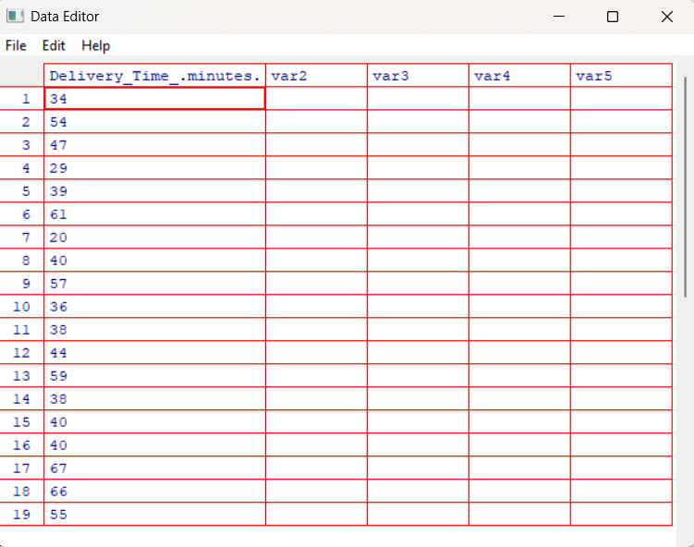

2.

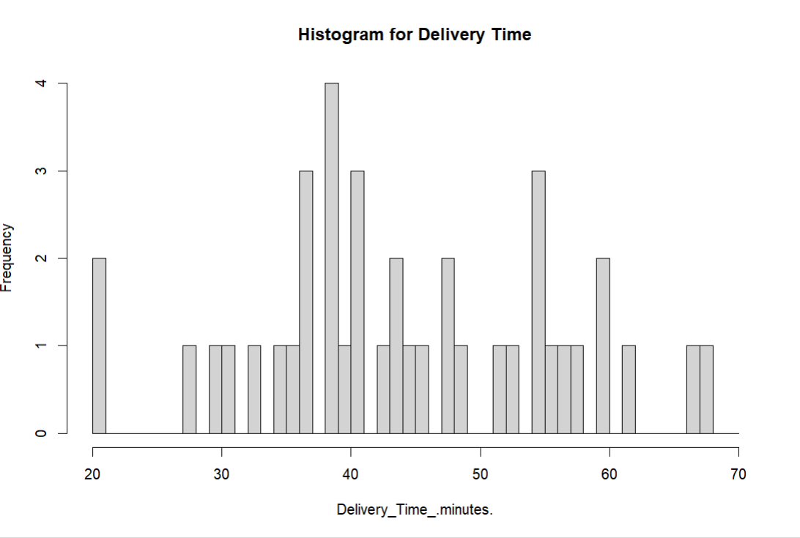

3.

Distribution is almost symmetric. Has a slight skewness to the right.

4.

